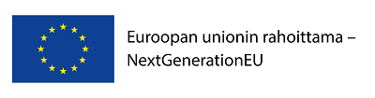

CHALLENGE COMPETITION FOR LEADING COMPANIES 2021

Contents

1. Background information 2
2. Purpose and scope of the competition 3
3. Principles of funding 4
3.1. Funding from Business Finland to a leading company 4
3.2. Funding from Business Finland for other members of the ecosystem and for pilot environments 5
3.3. EU and Nordic funding for leading companies and ecosystem partners 5
4. Two-phase competition: participation and selection of winners 6
4.1. Submitting entries for the first round of the competition 6
4.2. Oral presentation (pitch) 7
4.3. Selection for the second round (negotiation phase) 7
4.4. Final competition proposal/funding application and decision 7
4.5. Selection criteria 7
5. Competition schedule 8

APPENDIX I Template for the first phase of the competition
APPENDIX II Pitch template/model
APPENDIX III More information about the DNSH requirement (Do No Significant Harm)

Update 8.11.2021, page 3: Commission exclusion list added. The same information has also been sent direct to the Leading companies that are still in the competition

- Background information
Finland’s expenditure on research, development and innovation is around 2.8% of its GDP, while the target set in the Government Program is 4% by 2030. Business Finland seeks to contribute to the achievement of this target through this competition, among other measures. Large companies play a key role in achieving the target.
Business Finland launched the first challenge competition for leading companies at the beginning of 2020. Six projects from seven companies were selected as the winners, which will receive a total of EUR 120 million in funding from Business Finland. The leading companies are ABB, Fortum and Metsä Group, Kone, Neste, Nokia and Sandvik. These companies are committed to increasing their RDI investments by around EUR 500 million by 2025. They are aiming to hire more than 600 new employees in RDI (research, development and innovation). The leading companies are committed to building networks with at least 300 ecosystem partners. The networks are seeking to launch close to 300 new projects. More information:
https://www.businessfinland.fi/en/for-finnish-customers/services/funding/funding-for-leading-companies-and-ecosystems
Business Finland launched a new challenge competition round for leading companies in the beginning of June 2021. The challenge competition entries are expected to have a significant impact on the RDI (4%) and employment (75%) targets of the Government Program. The goal is for companies to increase their RDI operations in Finland significantly and create new jobs and ecosystems for new business operations worth billions of euros, in addition to promoting the green transition in Finland. The winning projects will be funded to a significant degree from the EU Recovery and Resilience Facility (RRF) in accordance with the Sustainable Growth Program for Finland. Funding decisions can be made once the Council of the European Union has approved Finland’s Recovery and Resilience Plan and the budget containing the funding has been approved by the Parliament of Finland.
- Purpose and scope of the competition
Principles of the competition:
For whom? | - For leading companies with global operations and plans to significantly expand RDI activities in Finland.
What is funded? | - Development of solutions with significant impact on global competitiveness in collaboration with an ecosystem.  - Clear and challenging missions, the realization of which require several sub-projects, partners and long-term efforts.
Funding | - Grants for leading companies for research-based projects.  - Duration 3 to 5 years. Up to EUR 20 million per company and up to 50% of expenditures.  - No requirement on parallel projects or purchased services, but notable spillover and effects on the ecosystem must be demonstrated (particularly on SMEs and research organizations).  - Total funding for the challenge competition is EUR 60 million in 2021, to be allocated between 3 to 6 of the best and most impactful projects.
How? | - Two-staged challenge competition. The best ideas progress from the initial concept stage. Business Finland’s jury selects the winners and the projects to receive funding.  - Impact targets include increases in R&D&I activities and investment in Finland by the leading company and ecosystem, other additional R&D&I investments, activities that increase project impact, and other socio-economic impacts.  - Payments only if the mutually agreed targets have been reached
The projects suggested by the leading companies participating in the competition must provide solutions to major future challenges, either to missions or significant technological challenges, in addition to having a significant impact on Finland’s competence, competitiveness and investment in RDI. Examples of mission-oriented RDI operations can be found in the Commission reports: Mazzucato – A problem-solving approach to fuel innovation-led growth and Mission-oriented research & innovation in the European Union.
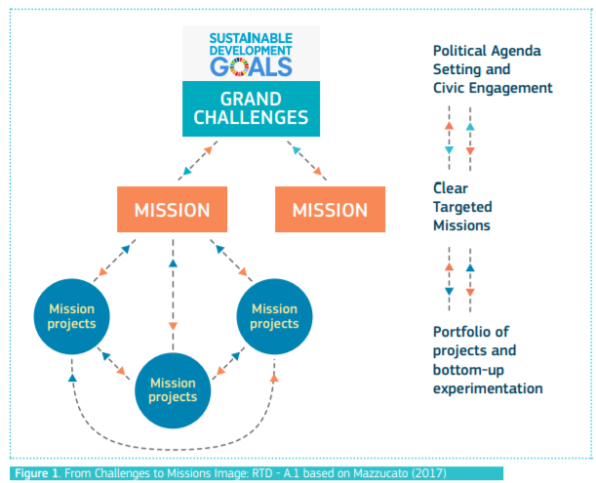From “A problem-solving approach to fuel innovation-led growth”
The plan is to use EUR 60 million for this competition in 2021. The maximum funding for an individual leading company is EUR 20 million. The funding earmarked for the competition is intended for at least three major projects. The results of this competition will also be used as basis for funding decisions in 2022. Sixty million euros will probably be available for additional funding decisions in early 2022.
The competition is not limited to any specific theme or technology topic, but entries are requested on topics related to the green transition in particular. Of the funding in 2021, around EUR 40 million will be targeted at projects promoting the green transition. Funding may be granted to one topic not related to the green transition.
Projects promoting green transition must meet the following requirement: “Research and innovation processes, technology transfer between companies and cooperation that focuses on the low-carbon economy and the ability to cope with and adapt to climate change.” In order to ensure that the investments under this component comply with the ‘Do no significant harm’ Technical Guidance (2021/C58/01), the eligibility criteria contained in terms of reference for upcoming calls for projects shall exclude the following list of activities:
- activities related to fossil fuels, including downstream use; Except projects under this measure in power and/or heat generation, as well as related transmission and distribution infrastructure, using natural gas, that are compliant with the conditions set out in Annex III of the ‘Do no significant harm’ Technical Guidance (2021/C58/01)
- activities under the EU Emission Trading System (ETS) achieving projected greenhouse gas emissions that are not lower than the relevant benchmarks; Where the activity supported achieves projected greenhouse gas emissions that are not significantly lower than the relevant benchmarks an explanation of the reasons why this is not possible should be provided. Benchmarks established for free allocation for activities falling within the scope of the Emissions Trading System, as set out in the Commission Implementing Regulation (EU) 2021/447.
- activities related to waste landfills, incinerators(* and mechanical biological treatment plants(**; (* This exclusion does not apply to actions under this measure in plants exclusively dedicated to treating non-recyclable hazardous waste, and to existing plants, where the actions under this measure are for the purpose of increasing energy efficiency, capturing exhaust gases for storage or use or recovering materials from incineration ashes, provided such actions under this measure do not result in an increase of the plants’ waste processing capacity or in an extension of the lifetime of the plants; for which evidence is provided at plant level.(** This exclusion does not apply to actions under this measure in existing mechanical biological treatment plants, where the actions under this measure are for the purpose of increasing energy efficiency or retrofitting to recycling operations of separated waste to compost bio-waste and anaerobic digestion of bio-waste, provided such actions under this measure do not result in an increase of the plants’ waste processing capacity or in an extension of the lifetime of the plants; for which evidence is provided at plant level.
- activities where the long-term disposal of waste may cause harm to the environment.
Only activities that comply with relevant EU and national environmental legislation can be selected
The funding and its monitoring will focus on the direct impacts of the project on new RDI investments and jobs in Finland and the creation of cooperation with SMEs and research organizations. The winning projects will be selected in line with these indicators, and the funding will be paid in line with their achievement and the costs incurred. In addition, attention will be paid to the impacts on the national economy, society, the green transition and the creation of new information and expertise. Business Finland will monitor the achievement of the latter goals, but they will not affect the payment of the funding or the continuation of the project.
The funding must also have a spillover effect on other operators in the ecosystem. Based on separate applications and a common road map, Business Finland may grant up to EUR 50 million in funding to other members of each ecosystem over a five-year period. Leading companies participating in the competition are expected to estimate how much other public funding is needed for other parties in the ecosystem. Such estimates are expected to cover at least the expectations for funding from Business Finland. Expectations can also be presented in terms of EU funding programs, the Academy and other sources of funding.
A leading company that receives funding agrees to produce communication material that, for example, Business Finland can use in its own communications. A leading company that receives funding also agrees to create a website for the project, where its progress and the creation of the partner network can be monitored.
- Principles of funding
  - Funding from Business Finland to a leading company
The maximum amount of funding per leading company and project is EUR 20 million. The maximum level of funding for projects that only include industrial research is 50% of the costs, and 40% for projects that mainly include industrial research. The normal funding criteria of Business Finland apply, but large companies are not required to purchase services from research organizations or SMEs. A leading company can use the funding for its own RDI costs. Funding from structural funds must not be targeted at the same costs. Funding from Business Finland for large companies: https://www.businessfinland.fi/en/for-finnish-customers/services/funding/research-and-development/research-development-and-piloting-big-companies
Projects of leading companies funded through the Sustainable Growth Program for Finland (RRF) must generally be completed no later than in December 2025.
The applicants are required to have measurable and significant cooperation with research organizations and/or SMEs. Funding granted to a leading company must not necessarily be used for research services or services purchased from SMEs, but the leading company must support and encourage research organizations and/or SMEs to participate in the resolution of the mission through their parallel projects, and it must also create concrete links to the flagships of the Academy of Finland, for example, and other similar national and international cooperation between higher education institutions or research institutes. The leading company must prepare a road map for cooperation and actively make its networks visible, beginning from the application stage.
The higher the promised absolute RDI increase, the more competitive the project will be considered to be. If the planned additional RDI investments and cooperation fail to materialize, funding for the leading company can be discontinued or reduced.
Funding for leading companies can also be applied for by a group of companies seeking to resolve the same major challenge, each from their own perspective. The maximum amount of such funding is EUR 20 million per company.
State aid principles for projects funded by Business Finland that are based on the EU’s IPCEI (Important Projects of Common European Interest) Communication will be provided separately for R&D-based investments related to first industrial deployments. It may not necessarily be appropriate to grant both IPCEI funding and funding for leading companies. This is a question of alternative paths in terms of R&D costs, but the situation is different for investments. IPCEI (PDF):
https://eur-lex.europa.eu/legal-content/EN/TXT/PDF/?uri=CELEX:52014XC0620(01)&from=EN.
  - Funding from Business Finland for other members of the ecosystem and for pilot environments
Business Finland is prepared to provide funding for ecosystems created around leading companies based on a common road map. A maximum of EUR 50 million in funding over a period of five years will be reserved for other members of the ecosystem. The leading company is responsible for activating projects and project parties to resolve the common challenge.
Business Finland provides funding to individual organizations or joint projects in line with its normal funding criteria: https://www.businessfinland.fi/en/for-finnish-customers/services/funding. Partnership projects must comply with the road map prepared by the leading company and must support the implementation of the leading company’s mission. Companies can apply for funding for their own RDI projects or joint co-innovation projects among several companies or between companies and research organizations. Research organizations can also apply for funding for an individual research project or a joint research project between several research organizations. Funding from the Sustainable Growth Program for Finland (RRF) will be used for partnership projects supporting the green transition.
More information about funding for partnership projects: https://www.businessfinland.fi/en/whats-new/calls/2021/partnership-model-funding-call-for-companies-and-research-organizations
Funding can also be granted for pilot environments (innovation infrastructures) for projects of leading companies and their partners. A separate application process for this purpose will be organized in 2022. In their applications, companies applying for funding for leading companies are requested to list any test and pilot environments whose creation or reinforcement would be important or necessary for the implementation of their road maps. The applicants are requested to specify what kind of contributions they would be prepared to make to create such environments and also to describe which other ecosystem operators should be involved in developing and/or operating test and pilot environments.
  - EU and Nordic funding for leading companies and ecosystem partners
Business Finland requires that European and other international sources of funding and cooperation networks are used as effectively as possible for funding the project. Examples of funding sources and networks:
European funding programs and networks (e.g., Horizon Europe, Eureka, ESA, CEF, InvestEU): https://www.eurahoitusneuvonta.fi/en/frontpage
EU Innovation Fund for the demonstration of low-carbon technologies: https://ec.europa.eu/clima/policies/innovation-fund_en
European Investment Bank (EIB, EIF): https://www.eib.org/en
Nordic cooperation (Nordic Innovation, NordForsk, Nordic Energy Research, Nordic Council of Ministers): https://www.nordicinnovation.org/programs, https://www.nordforsk.org/en, https://www.nordicenergy.org/

- Two-phase competition: participation and selection of winners
The application process has two phases. During the first phase, the idea/mission and the impacts of the solution on Finland are presented, along with the main features of the suggested solution and the core group of the potential ecosystem.
The applicants will be invited to present their idea orally to a panel compiled by Business Finland, and the panel will select the proposals to be invited to further negotiations based on the written application and the oral presentation (pitch). The idea and, especially the implementation plan, will be discussed in more detail during the further negotiations. The best projects will be asked to submit their final applications for funding.
  - Submitting entries for the first round of the competition
All participants must use the application template provided in Appendix I. The project proposal can be made in Finnish, Swedish or English. The proposal submitted in the first phase is not a funding application. It is a confirmation of participation in the idea competition.

The first-phase competition proposal (written project description in accordance with the application template provided in Appendix I + tentative pitch deck in accordance with Appendix II) must be received by Business Finland by 11.59 pm on September 1, 2021. The pitch deck can be supplemented before the actual pitch presentation.

Competition proposals are requested to be submitted primarily by email to kirjaamo@businessfinland.fi or by using a secure connection at https://asiointi.businessfinland.fi/suojaposti. The following must be taken into account:

- The applicant’s name and the case ID 1/35/2021 must be indicated clearly in the subject field of the email: “APPLICANT’S NAME: Challenge competition for leading companies – 1st round of competition 1/35/2021”
- The maximum size of the email message, including attachments, is 9 MB. The files can be compressed (Winzip). The files should be submitted primarily as .pdf and .tif documents. The files can also be submitted as .rtf files or .doc and .docx files (Word), .xls and .xlsx files (Excel) and .ppt and .pptx files (PowerPoint). When using email, the competition proposal is deemed to have been received by Business Finland once the message(s) and attachments are available in a readable format in the email account of the record office at Business Finland.
Applications can also be submitted by mail or in a closed envelope to the reception desk at Business Finland:
Business Finland/record office
P.O. Box 69 (Porkkalankatu 1)
00101 Helsinki

  - Oral presentation (pitch)
As a rule, all participants in the first phase will be invited to present the key points of their application orally. However, Business Finland can decide not to invite an applicant if they clearly fail to meet the goals of the competition. The PowerPoint template provided in Appendix II is used for the presentation.

Business Finland will schedule 20 minutes for the presentation and at least 20 minutes for interviews. The applicants are requested to indicate the three most suitable times in their offer. Available times:
 | Thursday, September 9 | Friday, September 10 | Monday, September 13 | Tuesday, September 14 | Wednesday, September 15 | Friday, September 17 | Monday, September 20
Morning

Afternoon

  - Selection for the second round (negotiation phase)
A panel compiled by Business Finland will score all proposals and oral presentations in accordance with the criteria provided in section 4.5. The proposals with the highest scores will be invited to further negotiations. All participants will be provided with feedback. The proposals submitted to the competition and their evaluations are confidential. At this stage, Business Finland will only publish information about the competition on a general level. The names of the participants or those selected for the second round will not be disclosed.
Business Finland will assess the credibility and feasibility of the information provided by the applicants. In assessing the proposals, Business Finland may also use information other than that provided by the applicants, in addition to its views on the feasibility and time horizon of the information, any risks involved and other aspects related to the desired impacts.
  - Final competition proposal/funding application and decision
There are likely to be two rounds of coaching discussions/negotiations.
The selected companies will be requested to submit their final funding applications (project plan and cost estimate, including the intermediate goals and payment criteria negotiated with Business Finland). The funding application is submitted via Business Finland’s electronic system. The template for the project plan to be attached to the funding application will be provided to the selected companies. After the template has been filled out, it must be saved as an attachment in Business Finland’s electronic system.
Funding from Business Finland is always discretionary. The funding decision will be made in accordance with the selection criteria provided in section 4.5 and Business Finland’s normal RDI funding criteria.
The funding decisions are expected to be made by the end of December. After the funding decision has been made, the name of the recipient will be published, along with a summary of the mission to be resolved and the impacts.
The leading companies are expected to actively communicate about the matter and prepare a communication plan. They must also create a dedicated website for the project, among other requirements.
  - Selection criteria
Selection criteria in the two phases:

- Competition (selection of applicants): impact
- Increase in RDI investments in Finland*, credibility of the increase (strategy and the management’s commitment)
- Other impacts
- Export potential for Finland (leading company + ecosystem)
- Added value provided by funding from Business Finland
Around EUR 40 million of the funding will be targeted at projects supporting green growth. These projects are expected to describe their positive impacts on a low-carbon economy and the ability to cope with and adapt to climate change.
* The purpose of the competition is to encourage new RDI investment in Finland. The assessment concerns direct impacts on the company’s new RDI investments (salary expenditure related to R&D operations, purchased services, other operating expenditure and investment and acquisition costs) in particular, as well as all indirect impacts (the creation of new expertise and hubs for expertise, new professorships, patents, theses, the extent of the network, new companies, business growth, environmental impacts, health effects, etc.)
- Evaluation of funding applications: impact and the quality of the action plan
- The criteria used during the first phase, plus the following:
- Quality and feasibility of the leading company’s own project plan
- Planned measures and commitment to ecosystem development (road map)
- Plan to use other funding (Academy of Finland, EU, etc.)
The various sections of the competition proposals will be evaluated on a scale of 1–5 as follows: 1 (incomplete), 2 (poor), 3 (rather good), 4 (good) and 5 (excellent), at 0.5-point intervals. The final scores will be determined by a consensus meeting in which the reviewers of the proposals will participate. Business Finland will prepare a ranking list and will select the candidates and recipients of funding based on the scores given by the reviewers.
- Competition schedule
- The challenge competition will open in June 2021; briefing on June 2, 2021 at 2 pm
- Deadline for first-round proposals: September 1, 2021 at 11.59 pm
- Company pitches and selection for further negotiations: September 2021
- Negotiations with the selected companies in October–November, final funding applications in November 2021
- Funding decisions for the leading companies in December 2021 (EUR 60 million)
- Funding decisions for other ecosystem operators between 2022 and 2025

- The companies on the reserve list will be invited for negotiations in autumn 2021. Funding decisions for these projects will be done early 2022.

APPENDIX I: TEMPLATE FOR FIRST-PHASE PROPOSALS

First-phase proposal: cover page + max. 12 pages and pitch deck
Notes and additional information are permitted, but the reviewers are only committed to assessing the actual 12-page proposal.
Chapters 1 and 2 of the proposal in particular will be examined during the first-phase evaluation.

COVER PAGE
GENERAL INFORMATION

Project name:

Name and Business ID of the participating organization:

Name and contact details of the accountable manager and the contact person (email and telephone number):

Does the project promote the green transition? Yes/No. If the answer is yes, describe in a few sentences how the project will promote a low-carbon economy and the ability to cope with and adapt to climate change.

The three most suitable times for pitching:
1:
2:
3:

SUMMARY (this summary is for the reviewers and is not public)

A summary of up to 2,000 characters.

FUNDING REQUESTED (amount)

Tentative cost estimate and funding to be applied for from Business Finland:

Estimated amount (range) of total funding needed by the ecosystem (Business Finland’s share)

IMPACT (planned increase in RDI operations in Finland for the whole group)
 | Reference year 2020 | 2021 | 2022 | … | … | …*
Group’s RDI personnel in Finland (number of employees)

Group’s RDI expenditure in Finland (EUR million)

Other impacts and impact pathways are described in writing in section 2 of the text section.
Any impacts on the green transition, in particular, must be described in detail.

* end year of the project
Competition proposal titles/sections (max. 12 pages in total)

- Mission and situation picture
  - Challenge/future need addressed by the project, uniqueness of the idea, market potential
  - Situation in Finland and globally, Finland’s competitiveness/competitive edge

- Impact and indicators
  - Impact on the goal of the Government Program to increase R&D expenditure to 4% of the GDP (new salary expenditure related to the leading company’s RDI operations in Finland, purchased services, other operating expenditure and investment and acquisition costs https://www.stat.fi/til/tkke/2018/tkke_2018_2019-10-24_laa_001_fi.html)
  - Commitment of the leading company’s management to the RDI increase mentioned above
  - Any impacts on the green transition
  - Other impacts on Finland (e.g., the creation of new expertise and hubs for expertise, new professorships, patents, theses, the extent of the network, new companies, business growth, improved competitiveness, tax revenues, environmental impacts, health effects)

- Necessary funding
  - Estimate of the BF funding and other funding necessary for the leading company
  - Estimate of the BF funding and other funding necessary for the leading ecosystem
  - Added value provided by funding from Business Finland**
  - Estimate of any funding needed for pilot environments (separate application process in 2022)

- What needs to be done – tentative road map to resolve the issue
  - What needs to be done, whose input is needed, roles of the leading company and the ecosystem
  - What is already available for support or collaboration? Measures and initiatives supporting the project in Finland and globally, particularly in the EU; funding provided by the EU
  - What national efforts should be made to promote the matter and what should be done internationally (RDI measures, legislation, standardization, etc.)
  - Description of any test and pilot environments whose creation or reinforcement would promote the achievement of the mission
  - Tentative schedule, including intermediate goals

- Project plan of the leading company (a very concise and clear description in the first phase of the competition)
  - An implementation/project plan of the leading company that includes a description of its own operations and the measures related to reinforcing the ecosystem and increasing expertise
  - Communication plan

**What is the change encouraged by funding from Business Finland (the extent and speed of the change and its scope in relation to the public funding needed and the scale of the market opportunity)?

APPENDIX II: Pitch template/model

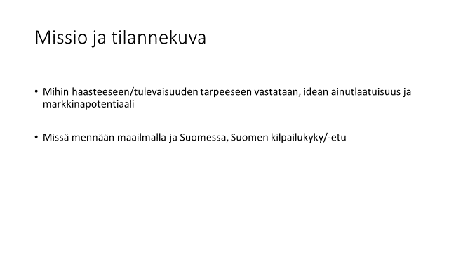 | 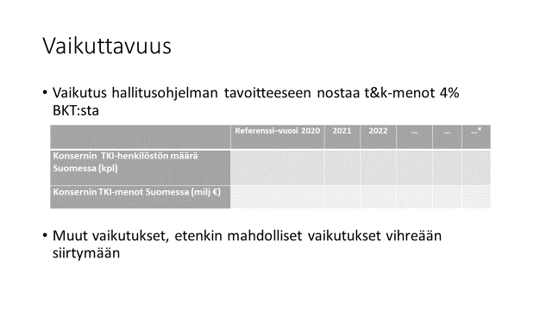
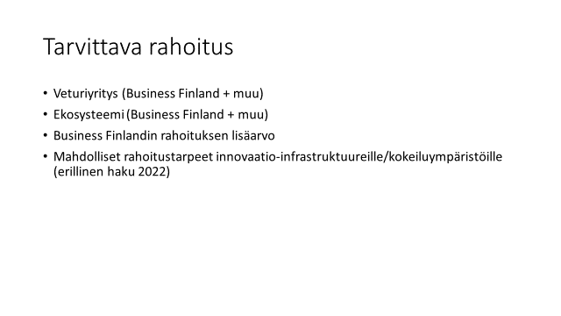 | 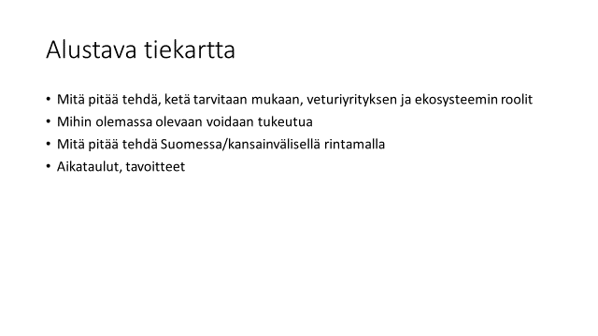
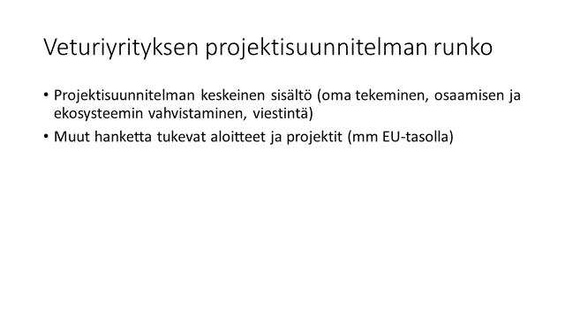 | 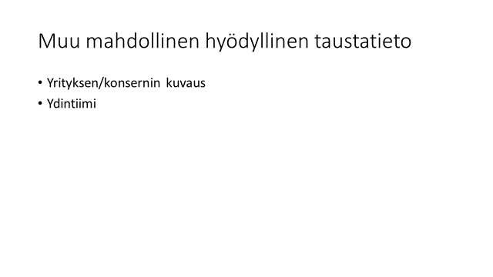

APPENDIX III: More information about the DNSH requirement (Do No Significant Harm)

Each project funded through the Sustainable Growth Program for Finland must meet the DNSH requirements. The EU Recovery and Resilience Facility (RRF) requires that no measures should cause significant harm to the environment. Economic activities are considered to cause significant harm to the following:
a) climate change mitigation,
- where that activity leads to significant greenhouse gas emissions;
b) climate change adaptation,
- where that activity leads to an increased adverse impact of the current climate and the expected future climate, on the activity itself or on people, nature or assets;
c) the sustainable use and protection of water and marine resources, where that activity is detrimental
- to the good status or the good ecological potential of bodies of water, including surface water and groundwater; or
- to the good environmental status of marine waters;
d) the circular economy, including waste prevention and recycling, where
- that activity leads to significant inefficiencies in the use of materials or in the direct or indirect use of natural resources such as non-renewable energy sources, raw materials, water and land at one or more stages of the life cycle of products, including in terms of durability, reparability, upgradability, reusability or recyclability of products;
- that activity leads to a significant increase in the generation, incineration or disposal of waste, with the exception of the incineration of non-recyclable hazardous waste; or
- the long-term disposal of waste may cause significant and long-term harm to the environment;
e) pollution prevention and control,
- where that activity leads to a significant increase in the emissions of pollutants into the air, water or land, as compared with the situation before the activity started; or
f) the protection and restoration of biodiversity and ecosystems, where that activity is
- significantly detrimental to the good condition and resilience of ecosystems; or
- detrimental to the conservation status of habitats and species, including those of Union interest.

Projects promoting the green transition that are selected for further negotiations must complete DNSH forms (Do No Significant Harm, Part 1 and Part 2), if necessary. The selected projects will be provided with more information about this.
Examples of how to complete DNSH forms are available in this document (p. 10 ->): https://data.consilium.europa.eu/doc/document/ST-6179-2021-ADD-1/en/pdf

https://vm.fi/en/sustainable-growth-programme-for-finland
https://op.europa.eu/en/publication-detail/-/publication/5b2811d1-16be-11e8-9253-01aa75ed71a1/language-en
https://ec.europa.eu/info/sites/info/files/mission_oriented_r_and_i_policy-a_rise_perspective.pdf
However, companies always have the right to apply for funding from Business Finland.
https://www.stat.fi/til/tkke/2018/tkke_2018_2019-10-24_laa_001_fi.html

