INSTRUCTIONS FOR PREPARING A PROJECT PLAN
Describe everything as briefly and precisely as possible! Do not alter the structure or tables of the project plan. Instead, you can add pictures and custom tables to your plan. It is required that you answer the questions in the project plan and application forms – just a link to a website is not sufficient.
****
CONTENTS OF THE PROJECT PLAN
Cover page
1. Project structure and schedule
2. Description of work packages
3. Project team
4. Project costs
4.1 Summary of human effort and salaries
4.2 Cost categories
4.3 Purchases services
5. Nature of the activities/assessment of the project’s research level
6. Project impact and the incentive effect of Business Finland’s funding
6.1 Incentive effect of Business Finland’s funding
6.2 Impact of the project on the company’s development
6.3 Other impacts of the project
6.4 Benefits of the Co-Innovation project (only if the project is a Co-Innovation subproject)
6.5 Benefits of the international joint project (only if the project is part of an international joint project)
6.6 How will the project affect the goals of the program/funding call/leading company’s roadmap (only if the project is participating in a program/funding call/leading company’s
6.7 Collaboration and network effects (for large companies only)
6.8 Applicant’s previous projects related to the same subject matter

****

Cover page
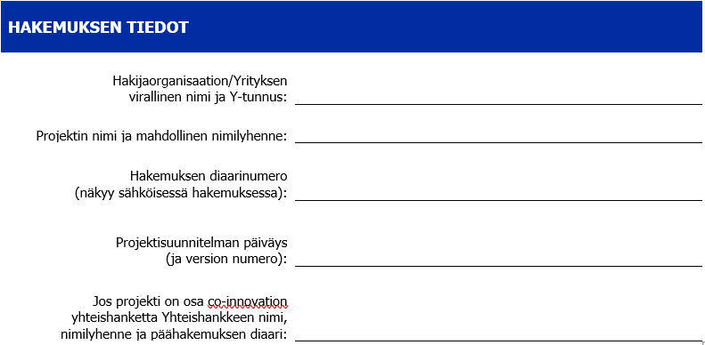
****
Project plan
1. Project structure and schedule
INSTRUCTIONS: Summarize in a few sentences the problem to be addressed and the novelty of the solution to be developed for the industry or the applicant.
A project consists of work packages. If you prefer, you can draw a picture of the work packages, demonstrating the order of the implementation of the work packages and their dependence on each other. See below for an imaginary example of the structure of a work package. It is recommended that one work package focuses on the preparation of how the results will be utilized (max 20% of the project budget). If you want, you can add a project timeline (e.g., a GANTT chart).
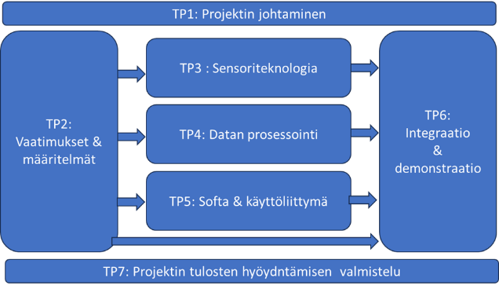

2. Description of work packages
INSTRUCTIONS: Describe the goals and content of the work packages as concretely as possible, describe how the work in the project will be implemented. Please copy as many work package templates as necessary.
Work package x | Name of work package
Start date (eg. month 1) | End date (eg. month 5) | Total workload, pm (person months) | Total costs of work package,€
Goals | Describe the goals of the work package in concrete terms. Set performance indicators (where possible, quantitative) for the goals
Description | Describe the work contained by the work package (what will you do and how?) and divide it into subtasks. What technologies, methods, data, and materials will you use?
Deliverables | Describe the outputs generated by the work package. A deliverable can be a report, a prototype, the completion of the features of a product/service, etc.

3. Project team
INSTRUCTIONS: Describe the company team that will implement the project (not subcontractors): individuals, titles and job descriptions, their skills and relevant work experience and role in the project

4. Project costs
INSTRUCTIONS: You should provide a cost estimate when filling out the application in the online service (screenshot below). The following pages contain tables that help you to fill out the cost estimate. Business Finland needs the information in the tables to assess the fundability of the project.
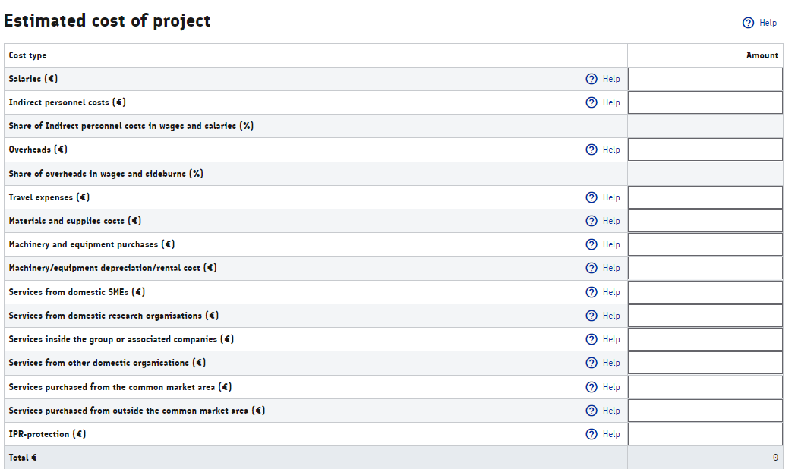

4.1 Summary of human effort and salaries
INSTRUCTIONS: Specify and estimate the costs as accurately as is possible
Employee’s name | Pm  WP1 | Pm  WP2 | Pm  WPx | Pm  WPx | Htkk  TPx | Total  (pm)
First name Last name, task in the project (confirmed and unconfirmed N.N.)
Total (person months)
TOTAL (€) |  |  |  |  |  | Enter the sum  in EUR in  “Salaries”
Make sure that the estimated person months correspond to the salaries (EUR) applied for, and enter the data in the “Salary” section in the cost table in the online service. As a rule, the salaries of the management and administration are included in overheads. Indirect personnel costs can be at most 50%, overheads between 10% and 50% depending on the company size. For additional information, see the instructions in the on-line application forms.
4.2 Cost types
INSTRUCTIONS: Specify and estimate the costs as accurately as is possible at this stage. Trips, materials, etc. can be allocated either to work packages or to the entire project without specifying them by work package.
Cost category | Description of the measures related to the costs | Total costs (€)  Enter the sums in the corresponding sections in the cost estimate table
Travel costs | WP1: Destination, purpose of the trip, included costs  WP2: xxx  … | xx €
Materials and  supplies | WP1: Purchased item, its purpose, supplier  WP2: xxx  … | xx €
Machinery and equipment purchases | WP1: Purchased item, its purpose, supplier  WP2: xxx  … | xx €
Equipment depreciations and  rental costs, incl. SaaS and cloud services | WP1: Piece of equipment, its usage % in the project. Describe the depreciation period of the equipment and the reasons for this, and the equipment’s use after the project.  WP2: xxx  … | xx €

Enter the total costs per cost type in the corresponding sections in the “Project Cost Estimate” table in the online service. Materials and supplies, as well as equipment purchases, are expenditure on supplies that do not have value after the project. Equipment depreciations can be made for equipment that retains its value after the project. The quantity of depreciations depends on the company’s depreciation policy, which defines the depreciation periods in the accounting. SaaS and cloud services and software licenses are equipment rentals by nature. For more detailed descriptions, see the funding terms and conditions (section 18): https://www.businessfinland.fi/en/for-finnish-customers/services/funding/guidelines-terms-and-forms/funding-terms

4.3 Purchased services
INSTRUCTIONS: Specify and estimate the costs as accurately as is possible at this stage. Purchased services can be allocated either to work packages or to the entire project without specifying them by work package
Cost category | Description of the purchased services related to the project | Total costs (€)
Services from domestic SMEs (€) | WP1: Purchased service, its purpose, supplier  WP2: xxx  … | xx €
Services from domestic research organizations (€) | WP1: Purchased service, its purpose, supplier  WP2: xxx  … | xx €
Services inside the group or from associated companies (€) | WP1: Purchased service, its purpose, supplier  WP2: xxx  …  It is important to specify the services purchased from different associated companies (foreign, domestic) | xx €
Services from other domestic organizations (EUR) | WP1: Purchased service, its purpose, supplier  WP2: xxx  … | xx €
Services from the European single market (€) | WP1: Purchased service, its purpose, supplier  WP2: xxx  … | xx €
Services from outside the European single market (EUR) (€) | WP1: Purchased service, its purpose, supplier  WP2: xxx  … | xx €
IPR protection (EUR) See the instructions below! | WP1: Purchased service, its purpose, supplier  WP2: xxx  … | xx €

Enter the total costs per purchased service in the corresponding sections in the table in the online application system. Purchased services constitute work outside the scope of the applicant’s own expertise or work outsourced from service providers independent of the applicant to ensure the best possible expertise for the requirements of the project.
Associated companies are companies in which the applicant has ownership or another interest connection; it can be a subsidiary or another company in the same group, for example. It is important to specify services purchased from different associated companies (foreign, domestic). Additional information: https://www.businessfinland.fi/en/for-finnish-customers/services/funding/guidelines-terms-and-forms/purchases-from-an-associated-company
IPR protection: SMEs may include the costs of the initial application for industrial property rights in the costs of purchased services. Costs related to the industrial property rights applications of large companies (including midcap companies) are not eligible. However, the costs related to novelty investigations are also eligible for larger companies. For more information, see the funding terms and conditions (sections 18 and 20): https://www.businessfinland.fi/en/for-finnish-customers/services/funding/guidelines-terms-and-forms/funding-terms
A purchase made for the project before the submission of the funding application can only be approved if the order agreement or the deed of sale contains a condition that the purchase will be canceled if the funding decision is negative. Even then, the costs are only eligible from the date of submission of the funding application at the earliest. For more information, see the Business Finland funding terms and conditions (section 9).

5. Nature of the activities/assessment of the project’s research level
 | Person months, pm | € | Assessment or description of the TRL level OR the work package’s research level
WP1 |  |  | This description/assessment is intended as a basis for the discussion between the BF expert and the company.  Describe the TRL level or the nature of work (industrial research/experimental development) at the beginning and especially at the end of the WP. It is easier to describe and assess this if research work and experimental development have been separated into their own work packages. No description of TRL/research levels are needed for work packages concentrating on administration or utilization of project results.
TP2
TPx
YHT:

INSTRUCTIONS: Fill in the table above. The information is required for the assessment of the project's eligibility for funding, funding percentage, and funding type (loan/grant). Research projects are usually funded with a grant and other projects with a loan. In a research project funded with a grant, at least 50% of the costs must be related to research work (TRL 2–4). Preparation for the utilization of the results can cover max 20% of the costs.

For each work package, assess either the so-called Technology Readiness Level OR whether the project will generate new knowledge (=industrial research) or apply existing knowledge (=experimental development, product development). The level of industrial research and Technology Readiness Levels (TRL) are connected as follows:
Basic research
• TRL 1 – basic principles detected
Industrial research (generation of new knowledge)
• TRL 2 – technology concept formulated
• TRL 3 – technology concept experimentally verified
• TRL 4 – technology verified under laboratory conditions
Experimental development (application of knowledge)
• TRL 5 – technology verified in an authentic environment
• TRL 6 – technology demonstrated in an authentic environment
• TRL 7 – a prototype demonstrated in operating environment
• TRL 8 – system up and running
Solution completed
- TRL 9 – functionality verified in the operating environment, ready for industrial manufacturing

For more detailed definitions of industrial research and experimental development, see Appendix 2.

6. Project impact and the incentive effect of Business Finland’s funding
6.1 Incentive effect of Business Finland’s funding
INSTRUCTIONS: How will funding by Business Finland improve the project? For example, would the project be realized without BF’s funding, would it be implemented in the same scope, will the funding speed up the implementation?
6.2 Impact of the project on the company’s development
INSTRUCTIONS: Summarize here shortly the responses you provided in the application forms. What do you plan to complete by the end of the project and how will the project’s results affect the development of the company’s know-how, products, services, and business? How will the company utilize the project’s results, what competitive advantage will the project generate, and how will the project improve the company’s opportunities to realize its growth plan? Will the results be utilized in future product development?
6.3 Other impacts of the project
INSTRUCTIONS: What are the other impacts of the project (on eg. employment, investments, exports, tax revenue, clean transition, digitalization).
In addition, answer the multiple-choice questions in the section “Impacts on sustainable development” in the application form in the online service.
6.4 Benefits of the Co-Innovation project (only if the project is a Co-Innovation subproject)
INSTRUCTIONS: What benefits will the applicant gain from the joint project and its participants? What does the applicant have to offer to the joint project? What project partners are necessary for the implementation of the applicant’s own contribution to the project and why? Which project partner needs the company’s contribution to the project to complete their own project and why?

6.5 Benefits of the international joint project (only if the project is part of an international joint project)

INSTRUCTIONS: Describe the collaboration, its significance, and the benefits of the international joint project. Who will be involved in the project and what will their role be? What results, impacts, and networks will be achieved thanks to the international joint project?

6.6 How will the project affect the goals of the program/funding call/leading company’s roadmap (only if the project is participating in a program/funding call/leading company’s partnership project)
INSTRUCTIONS: How does the project meet the goals defined in the call for applications or in the leading company’s roadmap? What are the benefits of the leading company/program for the company’s project?

6.7 Collaboration and network effects (for large companies only)
INSTRUCTIONS: What kind of network is being built in the project to support development work and what operators are included in the network? What services will be purchased from SMEs or research entities? How will the project affect the business of companies operating in the network and/or the development of expertise in research organizations?

6.8 Applicant’s previous projects related to the same subject matter
INSTRUCTIONS: Describe the achievements of possible previous projects funded by Business Finland and their realized impacts on business and export growth.
Furthermore, list the projects related to the solution to be developed that have been funded by the EU, the ELY Center, or other parties, along with their document numbers.

-----------

Additional information:
- Appendix 1: Questions in the online application forms with completion instructions
- Appendix 2: Clarifications of terminology and concepts
- Business Finland’s funding terms and conditions for RDI projects: https://www.businessfinland.fi/4b09e4/globalassets/finnish-customers/01-funding/08-guidelines--terms/funding-terms/yritysten_tutkimus-_ja_kehitystoiminnan_rahoituksen_ehdot.pdf

Appendix 1: Questions in the online application forms with completion instructions
The online system requires you to answer the following questions
BASIC APPLICATION INFORMATION
Responsible persons and contact persons
Programs and other connections (Business Finland’s program or campaigns)

CURRENT STATUS OF THE COMPANY
Description of the current status of the company (max 2,000 characters)
Briefly describe the current state of the company’s business. What are the company’s business model and revenue model? When did the current business start? Describe the company’s core operational team and management and their background.
You can append the company’s business plan and/or pitch deck to the application.
Company ownership and structure
Fill out the required information in the Excel file. Instructions for filling out the file are included in the Excel template.
Key business figures
Enter the business figures in the table in the on-line application form.
An SME must also include an up to 2 months old accounts ledger (a profit and loss statement and a balance sheet) and a cash flow forecast in accordance with the model in the appendix.
For projects lasting more than one year, required information also include an annual profit and financial forecast (tabs T2, T4 and T7 in the cash flow forecast table).
Growth vision (max 3000 characters)
Describe the company’s growth/renewal vision. What are the growth and internationalization plans/change and renewal plans to achieve the vision?
Business target figures
Enter the project’s impacts on business figures in the table in the on-line application form. Describe what kind of new exports/turnover/jobs will be generated by this particular project. Enter the year of market entry and the target year (the year when the turnover generated by the project will reach its peak), and then provide the annual target figures.

Explain how you have arrived at the figures in the business target table (max 3,000 characters).

PROJECT GOALS
Describe the project’s goals that will help the company to achieve its growth vision (max 3,000 characters).
Set concrete and measurable goals for the project. You will also discuss the goals with Business Finland during the processing of the funding application. The goals will be included in a positive funding decision, and their implementation will be monitored. The achievement of the goals will impact further funding from Business Finland. Set two types of goals for the project:
a) Concrete and measurable goals (2 or 3) related to the R&D content of the project that describe what you intend to complete by the end of the project. See below for a few example goals:
- The new solution x has been shown to work
- The pilot/demonstration of solution x has been implemented
- The company has developed x number of new methods or algorithms that can be utilized when developing new products
- The know-how developed in the project (specify) has increased (how?) and the company has prepared a plan for utilizing this know-how
- The project improves the performance of the new solution (specify) by xx% compared to the previous one
- Improved scalability aims at a xx% reduction in the amount of work and materials required
b) Concrete and measurable goals (2 or 3) related to the development of the company’s business as a result of and during the project. See below for a few example goals:
- The company has offered the developed solutions to identified potential customers, and their competitiveness has been evaluated in concrete terms and in a verifiable manner
- The company has concluded x new written customer agreements from outside Finland
- At the end of the project, the company has hired x professionals from a new field
- The company has planned/implemented a risk financing round to support the new business plan
- A product development or commercialization plan has been made to take advantage of the project’s results
- The company has started preparations for an offering with project partners
- New partnerships have emerged with the project’s designated partners, with a vision of developing a joint offering
- A documented plan has been created to significantly increase the turnover as a result of the solutions investigated in the project and the related new target markets
Market and customer need (max 3,000 characters)
What is the customer/market need that the product/service to be developed will address? Who will be its end users and paying customers? Describe the international target markets pursued by the company, their estimated size, and the growth prospects. Which countries (max 5 countries) do you plan to export to? How will you ensure during the project that you will constantly update your understanding of the needs of the international markets? Describe these in terms of the solution being developed, not in terms of the company’s entire product portfolio/business.
Approach/solution (max 3000 characters)
The novelty value of the solution. Describe the product/service/know-how/knowledge to be developed and what is new and innovative about it in comparison to existing or previously developed solutions on the market. Describe the company’s revenue model.
Benefits (max 3,000 characters)
What concrete benefits will the solution bring to customers and end users? How can the benefits be converted into revenue? Why should the customer pay for the solution (e.g., money/time savings, esthetic/ecological values, status)?
Competitive advantage (max 3,000 characters)
What are the competing solutions – also outside your own field? Who are the competitors? What competitive advantage will the solution bring to your company from the customer’s point of view?
Capabilities, new knowledge, and know-how (max 3,000 characters)
What new information and know-how will the project generate? What kind of new know-how does the company need to achieve the goal? What kind of new know-how can the company acquire through its networks?
Risks (max 3,000 characters)
What are the risks associated with the solution and its utilization, including possible geopolitical and regulatory risks? How will the company protect itself against these risks? What kind of barriers to market entry have you identified and how are you trying to mitigate them?
Intellectual property (max 3,000 characters)
What intellectual property rights does the company own? Does the company own all intellectual property rights related to the solution or do others (including owners and partners) own rights related to the solution? Will the product/service to be developed be protected by intellectual property rights (patent, design protection, trademark)? Describe the content of the possible freedom-to-operate search or how the company has ensured that the solution will not infringe the patents or other intellectual property rights of other operators.
PROJECT IMPLEMENTATION
Basic information
Project name, start and end date, implementation municipality
Project implementation
Attach a project plan according to the template in the on-line service
Impacts on sustainable development
Select the impacts of the project on sustainable development from the menu provided in the on-line service

COST ESTIMATE AND PROJECT FINANCING
Fill out the cost estimate table with the cost information specified and described in the project plan (salaries, trips, purchased services, materials, supplies). Choose whether to apply for a grant or a loan and describe the overall financing situation of the project – how much funding are you applying for from Business Finland and how have you taken care of self-financing?

APPENDIX 2: Clarifications of terminology and concepts
TERMINOLOGY
Term | Definition
Research and development | According to the OECD definition, all of the following characteristics must be met for the work to be considered R&D work:  1. Seeks new knowledge: The aim of R&D is to produce new knowledge and new results. 2. Creative: R&D is characterized by creativity, new ways of looking at a problem, and testing new concepts and hypotheses.  3. Uncertain outcome: R&D activities are characterized by uncertainty both in terms of the outcome and the resources needed. Success is guaranteed beforehand = not R&D.  4. Systematic: R&D activities are carried out systematically and budgeted and their implementation is monitored.  5. Reproducible and/or transferable: The data and results generated by R&D activities can be reproduced and transferred.  Statistics Finland’s definition: Research and development (R&D) generally refers to creative and systematic activities with the intention to increase knowledge and use this knowledge for new applications. The goal is to create something fundamentally new. https://stat.fi/meta/kas/t_ktoiminta_en.html  Routine and regular changes made to existing products, production lines, manufacturing processes, services, or other ongoing activities are not research and development, even if those changes imply improvements. Commission communication 2022/C 414/01
Industrial research | Industrial research refers to planned research or critical investigations aimed at acquiring new knowledge and know-how, with the purpose of using this knowledge to develop new products, processes, or services, or to significantly improve existing products, processes, or services, including digital products, processes, and services, in any line of business, field of technology, industry, or sector, including digital industries and technologies such as high-performance computing, quantum technology, blockchain technology, artificial intelligence, cybersecurity, big data and cloud computing; it covers the creation of components for complex systems and may include the construction of prototypes in a laboratory environment or in an environment involving simulated interfaces with existing systems, as well as the construction of pilot production lines when they are needed for industrial research and in particular for generic technology validation; https://www.finlex.fi/fi/laki/alkup/2023/20231173
Experimental development | Experimental development means the acquisition, integration, alteration and use of existing scientific, technical, business and other relevant knowledge and know-how with the aim of developing new or improved products, processes or services, including digital products, processes, and services, in any line of business, field of technology, industry, or sector, including digital industries and technologies such as high-performance computing, quantum technology, blockchain technology, artificial intelligence, cybersecurity, big data and cloud computing; this may also include, for example, activities aiming at defining, designing, and documenting basic concepts of new products, processes, or services; experimental development may include the prototypes of new or improved products, processes, or services, demonstration and pilot projects, testing and validation in an environment that represents practical operating conditions, where the primary goal is to make new technical improvements to products, processes, or services that are not yet for the most part established; this may include the development of commercially usable prototypes and pilot projects, where the prototype is necessarily the final commercial product and where its production for the sole purpose of demonstration and validation would be too expensive; experimental development does not include routine or periodic changes to existing products, production lines, manufacturing methods, services, or other ongoing activities, even if such changes imply improvements; https://www.finlex.fi/fi/laki/alkup/2023/20231173
Preparation  of utilization of results | As part of the project, Business Finland may fund customer and market analyses related to the solution to be developed, as well as other measures that support the opportunities to utilize the solution to be developed, such as the development of the organization’s operations or management. These measures may not exceed 20% of the approved cost estimate. https://www.businessfinland.fi/en/for-finnish-customers/services/funding/research-and-development/research-development-and-piloting
Goal | A concrete description of the goals that the project aims to achieve. You should set goals for the competences to be developed in the project and the presentable solutions generated by it (= the goals related to the content of the project). You should also determine how the company’s business know-how or business will develop during the project within the business area of the project.
Deliverable | Project deliverables are concrete outcomes and achievements generated by the project  (a memorandum, a measurement report, a prototype, etc.). Outputs demonstrate improved performance compared to the existing starting point.
Pm, Py | Person-month, person-year
TRL-level,  Technology Readiness Level | Technology readiness levels (TRL) are used to determine the degree of maturity of the technology: https://ec.europa.eu/research/participants/data/ref/h2020/wp/2014_2015/annexes/h2020-wp1415-annex-g-trl_en.pdf  https://www.nasa.gov/wp-content/uploads/2017/12/458490main_trl_definitions.pdf  The connection between TRL levels and industrial research and experimental development: Commission 2022/C 414/01 (footnote)

